1.Task-Install nginx and run nginx on port number 81.

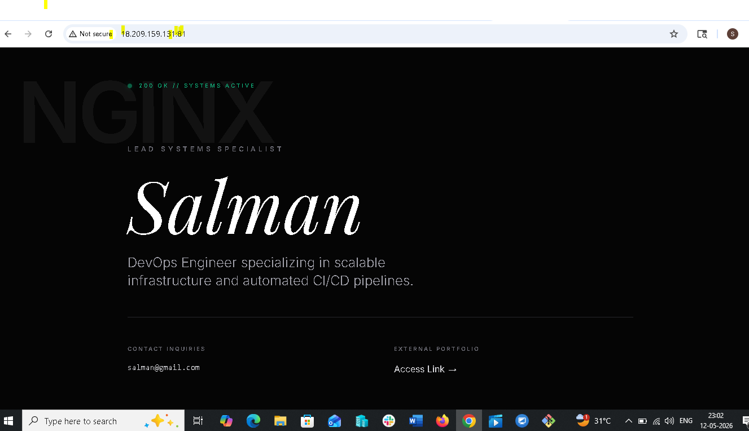

2.Task-Deploy a sample index.html file on nginx.


3.Task-Install Apache and run Apache on port number 82
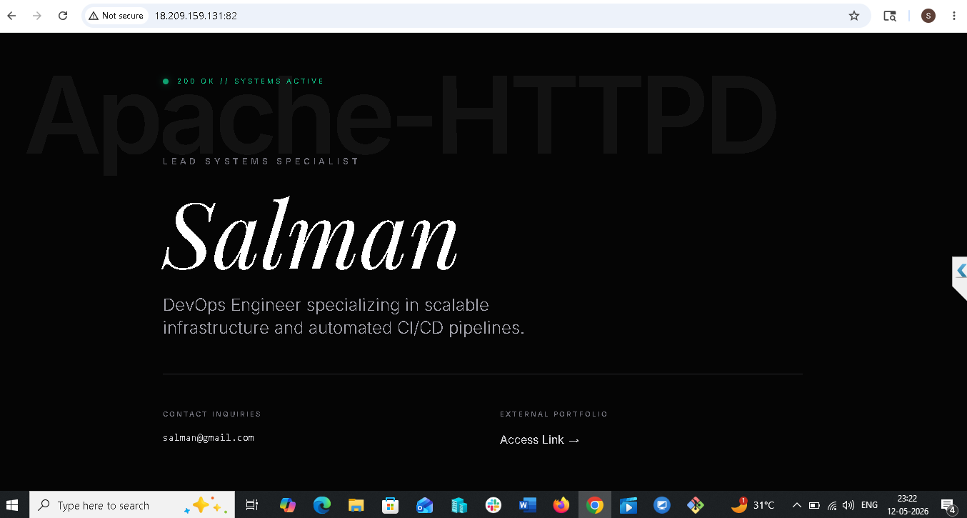

4.Task-Deploy a sample index.html file on Apache.


5.Task-Install Apache tomcat on port number 8082
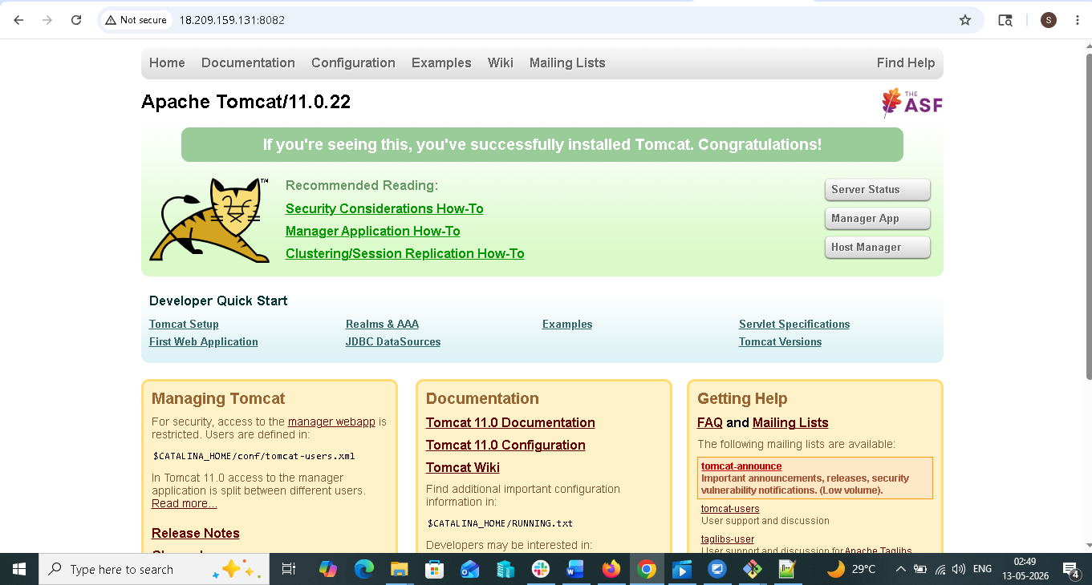

6.Task-Deploy a sample app on webapps
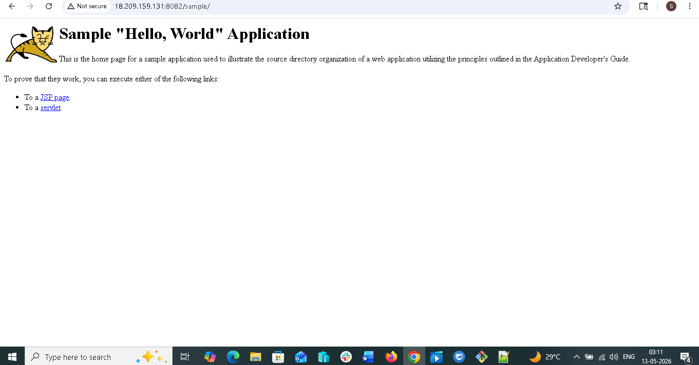

7.Task-Create a tomcat.service file for tomcat.

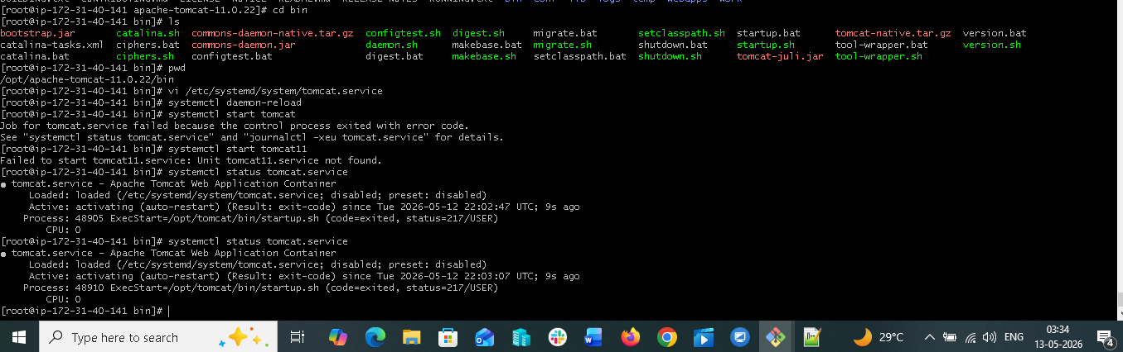

8.Task-Configure HA Proxy server
